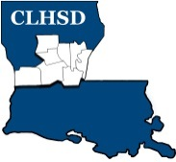
Central Louisiana Human Services District
Board Meeting Agenda
April 7, 2022

- Call to Order/Quorum
- Prayer/Pledge

- Read and Approve April 2022 Meeting Agenda
Solicit Public Comment Requests

- Approval of Minutes
March 2022 Board Meeting Minutes / Board Meeting & Retreat Minutes
- District Reports

  - Financial Report H1
  - ED Monthly Report H2

- Policy Reviews
Executive Limits- Rebecca Craig
  - II. H. Compensation and Benefits -H3
  - II. K. Community Relationships - H4 and H4a (Community Engagement Report)

- Board Business
- Board Development/Training – Current Contract Services
- Tier 2.1 – Covering Calendar Year 2021 due by May 15th
- Annual Ethics Training

- Next Month
- Annually Ethics training & tier 2.1 to be completed by the May meeting
- Board Member Self -Assessment distributed
- II.F. Emergency ED Succession (procedure)
- Training Topic – District Advisory Council Presentation

- Questions/Comments As Solicited

- Announcements
- Next meeting is May 5, 2022
- Adjourn

